**TASK-05**

**Sum of sine and cosine of angle.**

**EXPLANATION:**

The program takes angle in degrees and calculates value of sum and displays value as output.

**INPUT:**

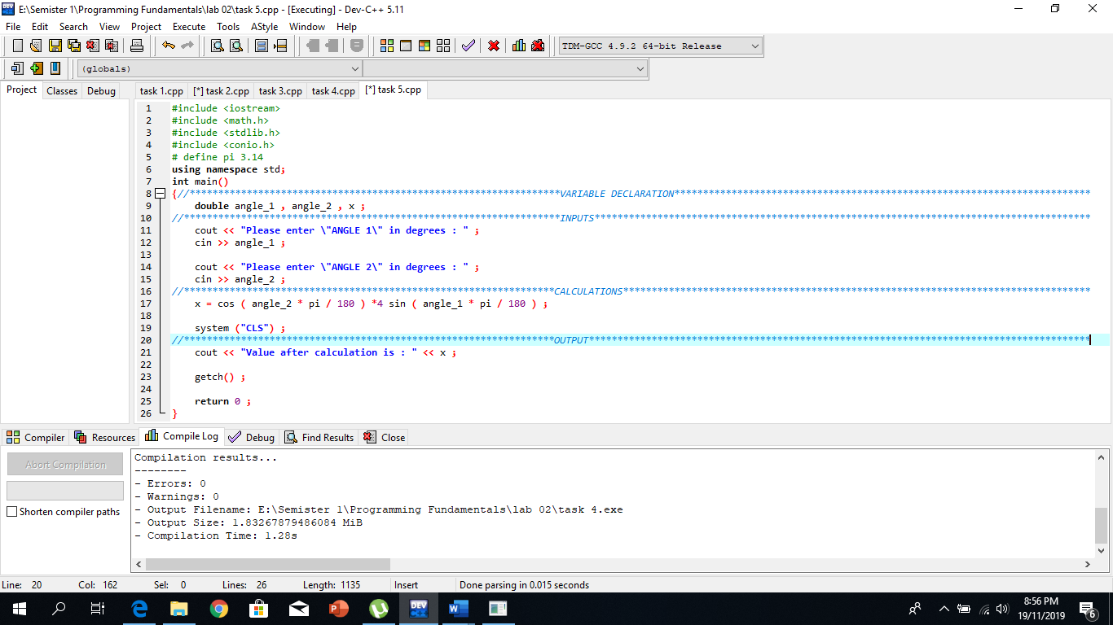

**OUTPUT:**

